Q1 Write a program to calculate the sum of first 10 natural number.

package Day5Assignment;

public class SumOfNaturalNum {

public static void main(String[] args) {

int a=0;

System.***out***.println("Sum of the first 10 Natural numbers");

for(int i=1;i<=10;i++)

{

a=a+i;

}

System.***out***.println("Sum is:"+a);

}

}

OUTPUT

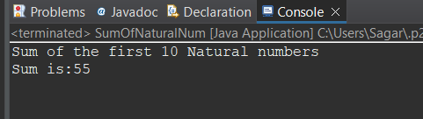

Q 2 Write a program that prompts the user to input a positive integer. It should then print the multiplication table of that number.

package Day5Assignment;

import java.util.Scanner;

public class MultiplacationaTable {

public static void main(String[] args) {

int i;

Scanner s=new Scanner(System.***in***);

do {

System.***out***.println("Enter Only poistive Number");

i=s.nextInt();

}while(i<0);

for(int j=1;j<=10;j++)

{

System.***out***.print(" "+j*i);

}

s.close();

}

}

OUTPUT

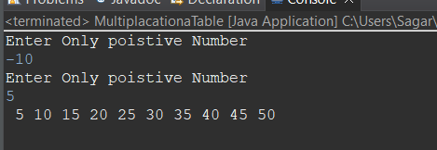

Q 3 Write a program that prompts the user to input an integer and then outputs the number with the digits reversed. For example, if the input is 12345, the output should be 54321

package Day5Assignment;

import java.util.Scanner;

public class ReversDegit {

public static void main(String[] args)

{

int i;

Scanner s=new Scanner(System.***in***);

System.***out***.println("Enter Number :");

i=s.nextInt();

System.***out***.println("Reverse Number:");

int rem=0;

while(i!=0)

{

rem=i%10;

i=i/10;

System.***out***.print(rem);

};

s.close();

}

}

OUTPUT

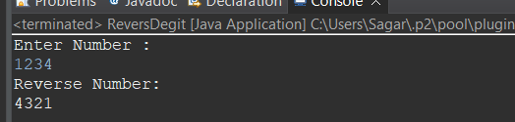

Q 4 Write a do-while loop that asks the user to enter two numbers. The numbers should be added and the sum displayed. The loop should ask the user whether he or she wishes to perform the operation again. If so, the loop should repeat; otherwise it should terminate.(while loop)

package Day5Assignment;

import java.util.Scanner;

public class UserNumAddition {

public static void main(String[] args) {

int a,b;

Scanner s=new Scanner(System.***in***);

String d;

do {

System.***out***.println("::::Add Two Numbers::::");

System.***out***.print("Enter First Number: ");

a=s.nextInt();

System.***out***.print("Enter First Number: ");

b=s.nextInt();

int c=a+b;

System.***out***.println("Addition Of The Two Numbers is:"+c);

System.***out***.println("");

System.***out***.println("You want perform addition again then write YES and to exit write NO");

d=s.next();

}while(d.equalsIgnoreCase("yes"));

System.***out***.println("===Program Terminated===");

}

}

OUTPUT

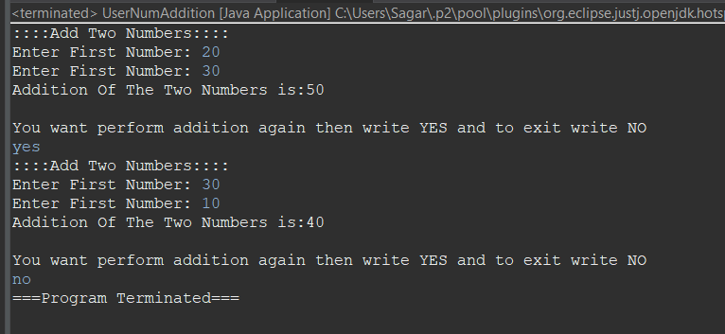

Q 5 Write a program to print out all Armstrong numbers between 1 and 500. If sum of cubes of each digit of the number is equal to the number itself, then the number is called an Armstrong number.  
For example, 153 = ( 1 * 1 * 1 ) + ( 5 * 5 * 5 ) + ( 3 * 3 * 3 )

package Day5Assignment;

public class AmstrongNum1to500 {

public static void main(String[] args) {

int rem=0,add=0;

System.***out***.println("Armstrong Numbers From 1 to 500");

for(int i=1;i<=500;i++)

{

int j=i;

add=0;

while(j>0)

{

rem=j%10;

j=j/10;

add=add+(rem*rem*rem);

}

if(i>1 && add==i)

{

System.***out***.println(" "+add); }

}

}

}

OUTPUT

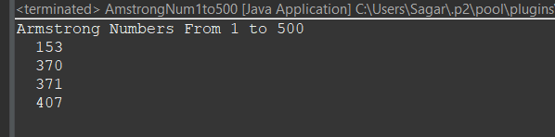

Q 6 Write a program to print Fibonacci series of n terms where n is input by user :  
0 1 1 2 3 5 8 13 24 .....

package Day5Assignment;

import java.util.Scanner;

public class FibonacciSerise {

public static void main(String[] args) {

Scanner s=new Scanner(System.***in***);

String d;

do

{

System.***out***.print("Enter Number for Fibonacci Serise: ");

int x=s.nextInt();

int a=0,b=1;

System.***out***.print(""+a);

System.***out***.print(" "+b);

int count=0;

for(int i=1;i<=x-2;i++)

{

count=a+b;

a=b;

b=count;

System.***out***.print(" "+count);

}

System.***out***.println("");

System.***out***.println("If You Want Print Another Febonnaci Serise Write YES and for Exit NO");

d=s.next();

}while(d.equalsIgnoreCase("yes"));

System.***out***.print("==EXIT==");

}

}

OUTPUT

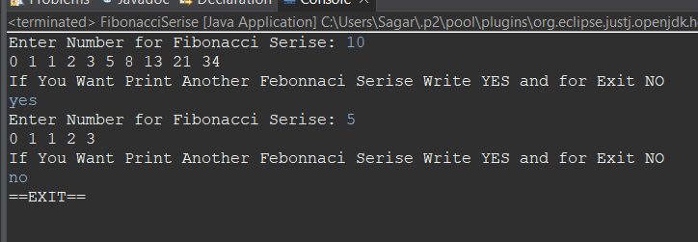

Q 7 Write a program to print following :

i)  
  
**********  
**********  
**********  
**********

package Day5Assignment;

public class StarPatterns {

public static void main(String[] args) {

for(int i=1;i<=4;i++)

{

for(int j=1;j<=5;j++)

{

System.***out***.print("*");

}

System.***out***.println("");

}

}

}

OUTPUT

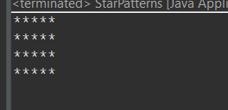

ii)  
  
*  
**  
***  
****  
*****

package Day5Assignment;

public class StarPatterns {

public static void main(String[] args) {

for(int i=1;i<=4;i++)

{

for(int j=1;j<=i;j++)

{

System.***out***.print("*");

}

System.***out***.println("");

}

}

}

OUTPUT

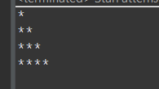

iii)  
  
         *  
      *   *  
     * *    *  
  *    *    *     *

package Day5Assignment;

public class StarPatterns {

public static void main(String[] args) {

for(int i=1;i<=5;i++)

{

for(int j=i;j<=5;j++)

{

System.***out***.print(" ");

}

for(int j=1;j<=i;j++)

{

System.***out***.print("* ");

}

System.***out***.println();

}

}

}

OUTPUT

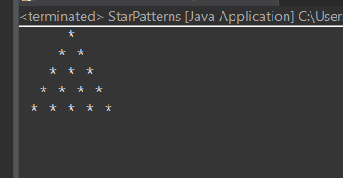

iv)  
  
        *  
      ***  
    *****  
  *******  
*********

package Day5Assignment;

public class StarPatterns {

public static void main(String[] args) {

int k=0;

for(int i=1;i<=9;i=i+2)

{ k=k+1;

for(int j=k;j<5;j++)

{

System.***out***.print(" ");

}

for(int j=1;j<=i;j++)

{

System.***out***.print("*");

}

System.***out***.println();

}

}

}

OUTPUT

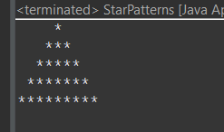

v)  
  
        1  
      222  
    33333  
  4444444  
555555555

public class StarPattern01 {

public static void main(String[] args) {

int k=0;

for(int i=1;i<=9;i=i+2)

{ k=k+1;

for(int j=k;j<5;j++)

{

System.***out***.print(" ");

}

for(int j=1;j<=i;j++)

{

System.***out***.print(k);

}

System.***out***.println();

}

}

}

OUTPUT

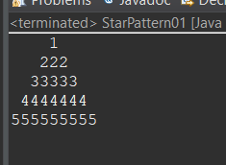

vi )   ABCDEEDCBA  
         ABCD  DCBA  
         ABC      CBA  
         AB         BA  
         A             A

public class ABCDSPattern {

public static void main(String[] args) {

int z=71,space=-1;

char x='F';

for(int i=1;i<=5;i++)

{ z--;

for(char a='A';a<z;a++)

{

System.***out***.print(a);

}

space++;

for(int v=2;v<=space+1;v++)

{

System.***out***.print(" ");

}

for(int v=2;v<=space+1;v++)

{

System.***out***.print(" ");

}

x--;

for(char b=x;b>='A';b--)

{

System.***out***.print(b);

}

System.***out***.println();

}

}

}

OUTPUT

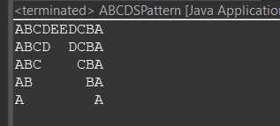

Q 8 Write a program in java to find the sum of the even and odd digits of the number which is given as input.

package Day5Assignment;

import java.util.Scanner;

public class AddEvenOddNum {

public static void main(String[] args) {

Scanner s=new Scanner(System.***in***);

System.***out***.println("Enter Number");

int a=s.nextInt();

int even=0,odd=0;

do

{

int p=a%10;

a=a/10;

if(p%2==0) {

even=even+p;

}

else

{

odd=odd+p;

}

}while(a!=0);

System.***out***.println("Sum Of The Even Numbers: "+even);

System.***out***.println("Sum Of The odd Numbers: "+odd);

s.close();

}

}

OUTPUT

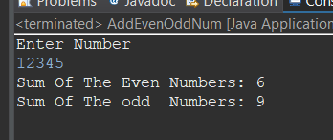

Q9 Write a program to check if given number is prime or not

package Day5Assignment;

import java.util.Scanner;

public class PrimeNumber {

public static void main(String[] args) {

Scanner s=new Scanner(System.***in***);

System.***out***.print("Enter Number:");

int a=s.nextInt();

for(int i=2;i<a;i++)

{

if(a%i==0)

{

System.***out***.print("You Enter Number is Not Prime Number:");

System.***out***.println();

break;

}

else if(i==a-1) {

System.***out***.println("Entered number is Prime Number");

break;

}

}

s.close();

}

}

OUTPUT

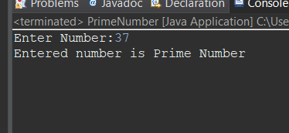

Q 10 write a program to print prime numbers between 2 to 20.

package Day5Assignment;

import java.util.Scannre;

public class PrintPrimeNumbers {

public static void main(String[] args) {

System.***out***.println("Prime Numbers Between 2 To 20");

for(int i=2;i<=20;i++)

{

for(int j=2;i<=20;i++)

if(i!=j&&i%j!=0)

{

System.***out***.print(i);

System.***out***.println();

break;

}

}

}

OUTPUT

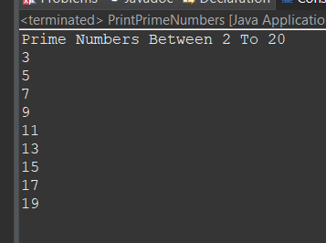

Q 11 Write program to find largest among three numbers

package Day5Assignment;

import java.util.Scanner;;

public class MaxNumBet3 {

public static void main(String[] args) {

Scanner s=new Scanner(System.***in***);

System.***out***.print("Enter First Numbers: ");

int a=s.nextInt();

System.***out***.print("Enter Second Numbers: ");

int b=s.nextInt();

System.***out***.print("Enter Third Numbers: ");

int c=s.nextInt();

int result= ( a>b ? (a>c?a:c) : (b>c?b:c));

System.***out***.print("Greatest Number Is:"+result);

}

}

OUTPUT

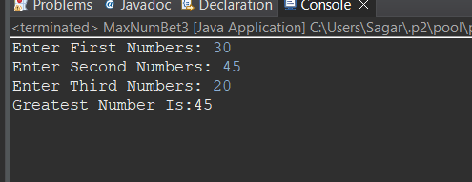

Q 12 Write a program to find sum of all integers greater than 100 and less than 200 that are divisible by 7

package Day5Assignment;

public class SumOfDivBy {

public static void main(String[] args) {

int a=0;

for(int i=100;i<=200;i++)

{

if(i%7==0)

{

a=a+i;

}

}

System.***out***.println("Sum Of The 100 To 200 Numbers that Divided By 7 Is: "+a );

}

}

OUTPUT

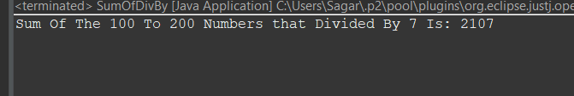

Q 13.    Write a Java program to print numbers between 1 to 100 which are divisible by 3, 5 and by both.

package Day5Assignment;

public class NumDivBy3And5 {

public static void main(String[] args) {

System.***out***.println("following Numbers Divided by 3 and 5: ");

for (int i=1; i<100; i++) {

if (i%3==0&&i%5==0)

System.***out***.print(i +", ");

}

}

}

OUTPUT

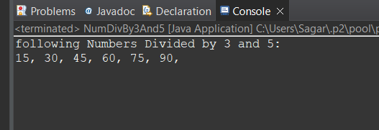

Q 14 create a menu driven application in java that show  
   "Add"        Add two number  
  "subtract"  Subtract two number  
  "Multiple"    Multiple two numbers  
  "Exit "           Exit

package Day5Assignment;

import java.util.Scanner;

public class CreateMenu {

public static void main(String[] args) {

Scanner s=new Scanner(System.***in***);

System.***out***.print("Enetr First Number: ");

int m=s.nextInt();

System.***out***.print("Enetr First Number: ");

int n=s.nextInt();

System.***out***.println("Menu 1 Add \n 2 Substract \n 3 Multiply \n 4 Divide");

int a=s.nextInt();

switch(a)

{

case 1 : System.***out***.println("Addition :"+(m+n));

break;

case 2 : System.***out***.println("Substraction :"+(m-n));

break;

case 3 : System.***out***.println("Multiply :"+(m*n));

break;

case 4 : System.***out***.println("Divition :"+(m/n));

break;

default :System.***out***.println("Wrong Entry :(");

}

s.close();

}

}

OUTPUT

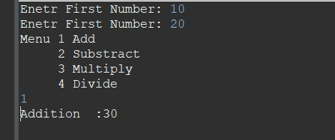

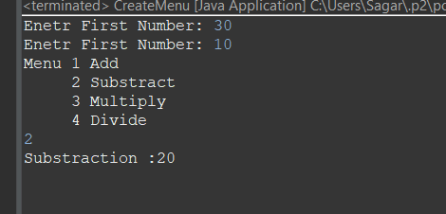

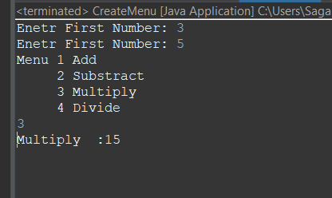

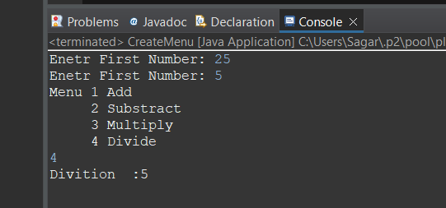

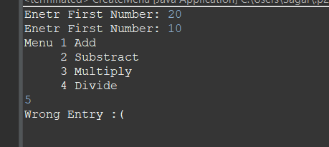

Q 15  Write a program to display first 1 to 20  even number on screen . Terminate the program when number 16 is found using break command .

package Day5Assignment;

public class TerminateAt16 {

public static void main(String[] args) {

for(int i=1;i<=20;i++)

{

if(i%2==0&&i!=16)

{

System.***out***.print(i+", ");

}

else if(i==16)

{

break;

}

}

}

OUTPUT

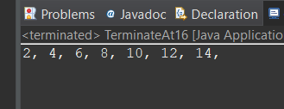

Q 16 Write a Java program that accepts two double variables and test if both strictly between 0 and 1 and false otherwise.

package Day5Assignment;

import java.util.Scanner;

public class NumBet0to1 {

public static void main(String[] args) {

Scanner s=new Scanner(System.***in***);

System.***out***.print("Enetr Number: ");

double a=s.nextDouble();

System.***out***.print("Enetr Number: ");

double b=s.nextDouble();

if((a>0&&b>0)&&(a<1&&b<1))

{

System.***out***.println("Enetered Numbers Is In between 0 To 1");

}

else

System.***out***.println("Enetered Numbers Is NOT In between 0 To 1");

}

}

OUTPUT

